1. onclick is used to call a js function :

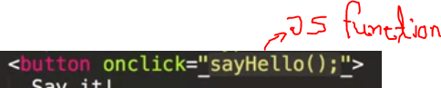

Now , js function could be: 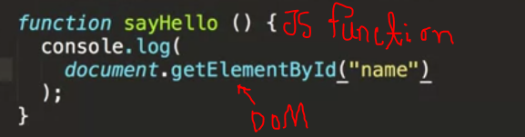

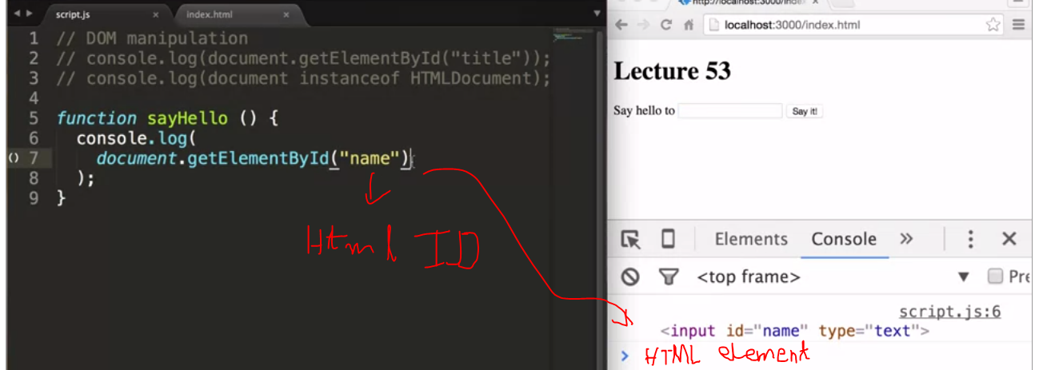

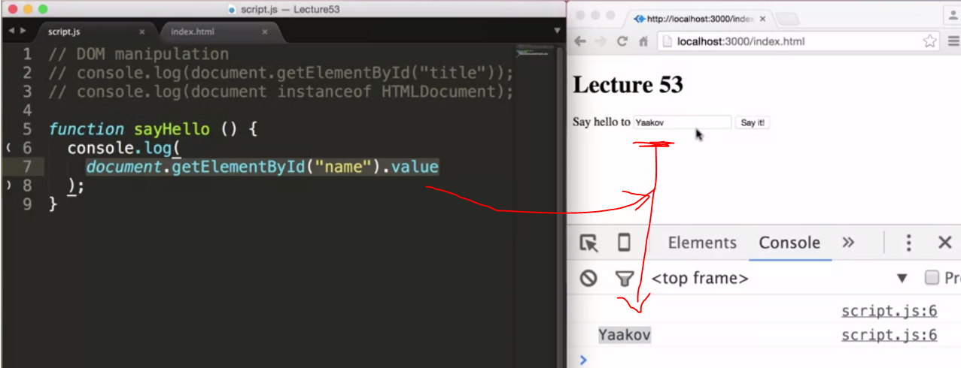

Now take the value and coustomize it: html , js

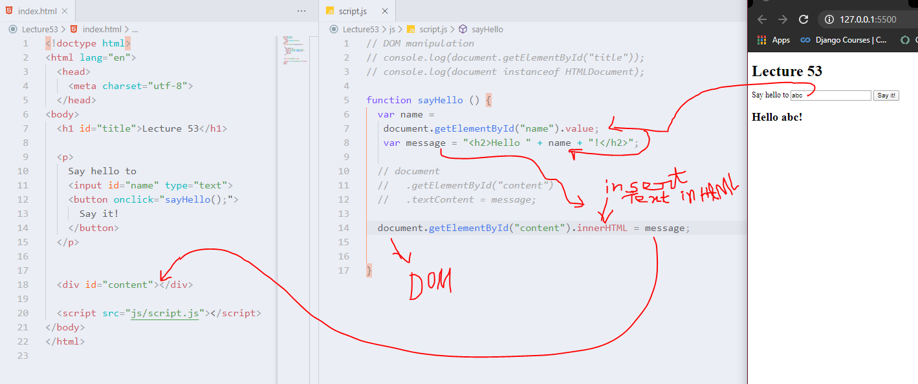

Here the ‘hello abc’ is bold

Because .innerHTML makes it inside <h1> tag.  
to make it simple text, use *.textContent*

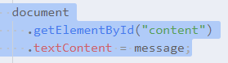

Now here we can do more:we can change the title “Lecture 53”:

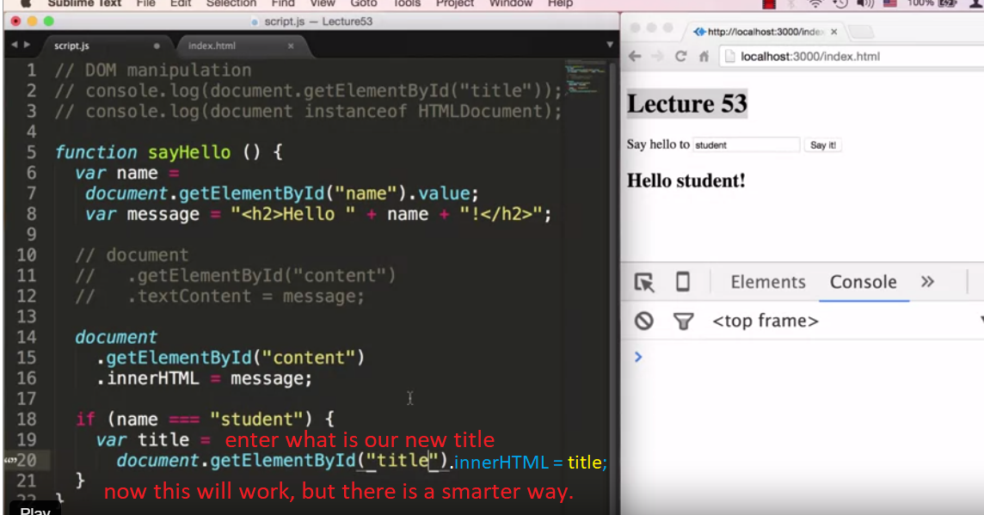

One other smarter way:

  if (name === "student") {

    var title = "av";

      document

**.**querySelector("#title") // css selector

**.**textContent=st;

  }

Or here, at first the var title will get the previous title and the add soming with it and publish

if (name === "st") {

    var title =

      document

**.**querySelector("#title")

**.**textContent;

    title += " & Lovin' it!";

    document

**.**querySelector("#title ") // here we also can use h1 instead of #title

//to point the html element. Because there

//is only one <h1> tag in html page

**.**textContent = title;

  }

}

This onclick function as used in django project to go some where and pass id of a database object:

onclick="window.location='{% url 'detail' i.id %}';

here i.id is database id

2. As like onclick there are other :

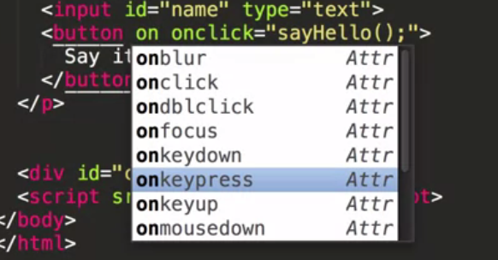

See link:<https://developer.mozilla.org/en-US/docs/Web/Events#Most_common_categories>

3.onblur : 

When the particular element loss the focus then commit a action

4. IN jquery:  
DOM manipulation is express by $

Basically

$(function ()

Means : *.addEventListener("DOMContentLoaded"...*

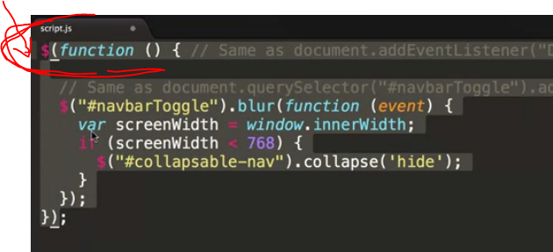

More about it in jquery folder

5. the jQuery dollar sign function also has another functionality, and

that is serves as a query selector

*Same as document.querySelector("#navbarToggle").addEventListener("blur",...*

 $("#navbarToggle")**.**blur(function (event)

6.to get the width of browser to have the break point :

window**.**innerWidth;